Theme – Holy Habit … making more disciples

The Book of Acts gives us ten clear instructions of how to become stronger and more faithful disciples. These are called ‘Holy Habits’ and they assist us in deepening our discipleship. Today we shall explore the tenth and last Holy Habit, Making more disciples.

Call to worship taken from Psalm 95 v 1,2

Leader Come and worship the Lord Jesus,
King of kings, yet servant of all.
All Come with your dreams, your longings, your hopes,
and all those on your hearts today,
to seek blessing and healing. Amen.

Hymn RS 285 O for a thousand tongues to praise

Opening prayers

Lord’s Prayer

Readings Acts 2:37-47
Matthew 28:16-20

Introduction to ‘Holy Habits
The process of Evangelism
Hymn
Jesus Christ is waiting,
waiting in the streets;
no one is his neighbour,
all alone he eats.
Listen, Lord Jesus,
I am lonely too.
Make me, friend or stranger,
fit to wait on you.
Jesus Christ is raging,
raging in the streets,
where injustice spirals
and real hope retreats.
Listen, Lord Jesus
I am angry too.
In the Kingdom's causes
let me rage with you.
Jesus Christ is healing,
healing in the streets;
curing those who suffer,
touching those he greets.
Listen, Lord Jesus,
I have pity too.
Let my care be active,
healing, just like you.
Jesus Christ is dancing,
dancing in the streets,
where each sign of hatred
he, with love, defeats.
Listen, Lord Jesus
I should triumph too.
On suspicion's graveyard
let me dance with you.
Jesus Christ is calling,
calling in the streets,
'Who will join my journey?
I will guide their feet.'
Listen, Lord Jesus,
let my fears be few.
Walk one step before me;
I will follow you.
John L Bell (born 1949) and Graham Maule (born 1958)
© 1988 WGRG, c/o Iona Community,
Offertory

‘Holy Habit’ of making disciples
- Bless, belong and believe
- Markers and milestones
- An expectation of Growth

Hymn RS 580 Lord you give the great commission

Prayers of Intercession

Hymn Christ is alive! Let Christians sing.
The cross stands empty to the sky.
Let streets and homes with praises ring.
Love, drowned in death, shall never die.
Christ is alive! No longer bound
to distant years in Palestine,
but saving, healing, here and now,
and touching every place and time.
In every insult, rift and war,
where colour, scorn or wealth divide,
Christ suffers still, yet loves the more,
and lives, where even hope has died.
Women and men, in age and youth,
can feel the Spirit, hear the call,
and find the way, the life, the truth,
revealed in Jesus, freed for all.
Christ is alive, and comes to bring
good news to this and every age,
till earth and sky and ocean ring
with joy, with justice, love and praise.
Brian Wren (born 1936)
© 1969, 1995 Stainer &amp; Bell Ltd
Closing Prayer

Blessing

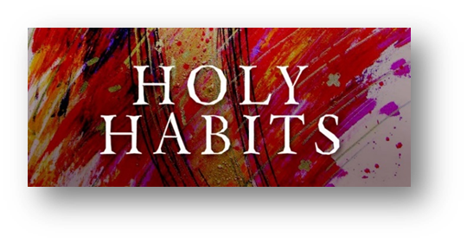

10. Making more disciples

