Theme – Holy Habit … Prayer

The Book of Acts gives us ten clear instructions of how to become stronger and more faithful disciples. These are called ‘Holy Habits’ and they assist us in deepening our discipleship. Today we shall explore the fourth Holy Habit, Prayer.

Call to worship

♫ Bless the Lord, Bless the Lord,
Bless the Lord, there is no other God (Repeat x 3)

Hymn RS 302 O breath of life come sweeping through us.

Opening prayers

Lord’s Prayer

Eternal Spirit:
Earth-Maker, Pain-bearer, Life-giver,
source of all that is and that shall be,
Father and Mother of us all.

Loving God, in whom is heaven.
The hallowing of your name
echoes through the universe!
The way of your justice
be followed by the peoples of the earth!
Your heavenly will be done by all created beings!
Your commonwealth of peace and freedom
sustain our hope and come on earth.
With the bread we need for today, feed us.
In the hurts we absorb from one another, forgive us.
In times of temptation and test, spare us.
From the grip of all that is evil, free us.
For you reign in the glory of the power
that is love,
now and forever.
New Zealand Prayer Book

A song to welcome the Word

Bring your questions, bring your feelings,
bring the things you think you’ve learned.
Here, with God, let’s search for meaning,
in encounter with God’s Word.
By these texts and their retelling,
heard through all we bring today,
may God grant fresh understanding
of the role we’re called to play. ©John Campbell
©Kevin Mayhew
Tune is what a friend we have in Jesus
Readings Luke 11:1-13

Introduction to ‘Holy Habits’ Lets Pray !

Hymn RS 495 Father hear the prayer we offer

Offertory
2nd Reading `Acts 2: 37-47

Fourth ‘Holy Habit’ … Who we are, is how we pray.
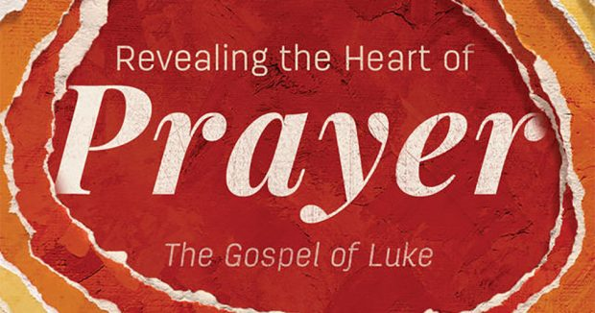

Hymn
Lay your healing hand upon me,
When my heart seems all alone;
Give me Strength, through Prayer and Praise
Accept the Love, that you have shown.

In my prayer life, Lord sustain me,
When the words are hard to find.
In your stillness, come be near me,
Tenderness to fill my mind.

When the world around is hurting,
and the pressures fill my time.
In my service and my witness,
Prayer enriches life, in kind.

On life’s journey, still my mind-
my heart, till I am one with you.
Then in one with all Creation
Hope and Love will bring me through.
©Ruth Dillon
Tune Servant Song – 87 87

Prayers of Intercession

Hymn RS 413 What a friend we have in Jesus
Closing Prayer

Blessing

May God’s blessing surround you each day;
as you trust Him and walk in His way;
May his presence within, guard and keep you from sin;
Go in peace go in joy go in love.

4. Prayer

