Theme – Holy Habit … Worship

The Book of Acts gives us ten clear instructions of how to become stronger and more faithful disciples. These are called ‘Holy Habits’ and they assist us in deepening our discipleship. Today we shall explore the ninth Holy Habit, Worship.

Call to worship (1 Women, 2 Men , 3 All)

♫ Bless the Lord, Bless the Lord,
Bless the Lord, there is no other God (Repeat x 3)

Hymn RS 118 Praise to the Living God

Opening prayers

Lord’s Prayer

A song to welcome the Word
Bring your questions, bring your feelings,
bring the things you think you’ve learned.
Here, with God, let’s search for meaning,
in encounter with God’s Word.
By these texts and their retelling,
heard through all we bring today,
may God grant fresh understanding
of the role we’re called to play.
©John Campbell
©Kevin Mayhew
Tune is what a friend we have in Jesus

Readings Deuteronomy 6:1-9

Ninth ‘Holy Habit WORSHIP
Worship as……. A way of life
Worship as …… An expression of devotion
Worship as……. An expression of spiritual energy

Hymn
The true Church is found where God's purpose is sovereign,
where people acknowledge God's will as supreme;
each under God's governance, trusting God's greatness,
beyond all the splendour earth's conquerors could dream!
The true Church is found where its preachers sincerely,
with true hearts and minds, are proclaiming God's Word;
where people are hearing and truly responding,
and yearning to live in the truth they have heard.
The true Church is found where the bread is still broken,
received by the people at Christ's own command,
with Christ truly present for those who receive it,
as though it is served by his own wounded hand.
The true Church is found where God's people acknowledge
the crucified Christ and submit to his call;
his chosen ones serve him, whose service is freedom,
and though worlds should perish, his Church shall not fall.
The true Church is found where God's people, united,
are joined in obedience to Christ, in whose name,
with love and good will they put trust in each other,
and prove by their own love, the love they proclaim!
The true Church is found where, without condemnation,
Christ's people love others, and hatred is healed.
They look for the good and seek Christ in each neighbour,
till Love's hidden purpose for all is revealed.
Alan Gaunt (born 1935)
© 2009 Stainer & amp; Bell Ltd
Tune Streets of Laredo
Offertory

2nd Reading Luke 4:16-21

Ninth ‘Holy Habit’ Rhythm and styles of worship

Hymn RS 497 Give to me Lord a thankful heart

Prayers of Intercession

Hymn Refrain (sung twice)
Singing, we gladly worship the Lord together.
Singing we gladly worship the Lord.
Those who are travelling the road of life
Sow seeds of peace and love.

Come, bringing hope into a world of fear,
A world which is burdened down with dread
A world which is yearning for a greater love
But needs to be shown the true way Refrain

Come bringing joyfully in both your hands
Some kindling to light the path to peace,
some hope that there is a more human world
Where justice and truth will be born. Refrain

Whenever hatefulness and violence
Are banished forever from our hearts.
Then will the world believe the day is near
When sadness and pain find their end. Refrain
Guatemalan traditional
Iona Community copyright
Closing Prayer

Blessing

The peace of the earth be with you,
the peace of the oceans too;
the peace of the rivers be with you,
the peace of the oceans too.
Deep peace falling over you;
God’s peace growing in you.

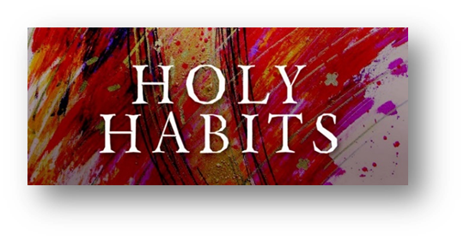

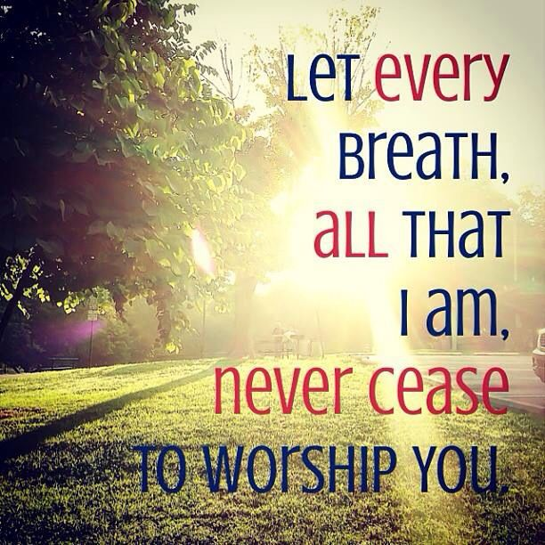
9. Worship

