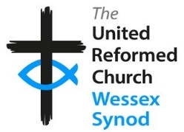

Stepwise Participant Form – Faith Filled Worship

Name:
Full postal address:
Email:
Tel: / Mobile:
Your local church:
Your URC Synod:

I am interested in attending the Stepwise stream – Faith Filled Worship.

I have completed the first Stepwise stream ‘Faith Filled Life’
- Please state which Synod organised the FFL group:
- Date FFL completed: (month/year)

If you are under 18, you are particularly welcome to become part of Stepwise. Please give your date of birth:

Consent
I give my consent for my data to be handled according to the Yes / No
Wessex Synod Data Privacy Statement.

I give my consent for my data to be passed to Church House for registration Yes / No
on the Stepwise hub. URC Data Privacy Notice.

Signature: __________________________________ Date: _____________________
(Participant)

Signature: ___________________________________ Date: _____________________
(signature of parent/guardian if participant is under 18 years)

Name of Parent/Guardian: ______________________________________________

Please return this form to the Development Team Administrator, Wessex Synod Office
Email: development@urcwessex.org.uk.
Post to: Wessex Synod Office, 120 Alma Road, Southampton, SO14 6UW.

