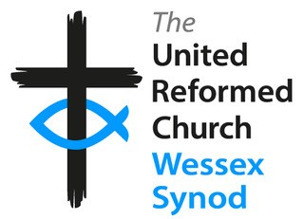

Stepwise Participant Form – Faith Filled Life

Name:
Full postal address:
Email:
Tel: / Mobile:
Your local church:
Your URC Synod:

I am interested in participating in ‘Faith Filled Life’ – the first stream in the Stepwise programme.

If you are under 18, you are particularly welcome to become part of Stepwise.

For Safeguarding purposes, it would be helpful to know your date of birth _________

Consent
I give my consent for my data to be handled according to the Yes / No
Wessex Synod Data Privacy Statement.

I give my consent for my data to be passed to Church House for registration Yes / No
on the Stepwise hub. URC Data Privacy Notice.

Signature: __________________________________ Date: _____________________
(Participant)

Signature: ___________________________________ Date: _____________________
(signature of parent/guardian if participant is under 18 years)

Name of Parent/Guardian: ______________________________________________

Please return this form to the Development Team Administrator, Wessex Synod Office
Email: development@urcwessex.org.uk.
Post to: Wessex Synod Office, 120 Alma Road, Southampton, SO14 6UW.

