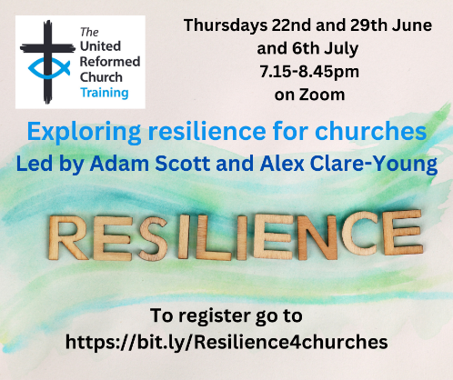

Three FREE Zoom sessions: EXPLORING RESILIENCE FOR CHURCHES.

URC Training- a collaboration between
Children and Youth Work and Education and Learning.

Thursday 22nd June - self-care and resilience. 7.15-8.45pm.
Led by Adam Scott, this first session will focus on personal resilience or self-care. Resilience is a word we use a lot, especially recently, and Adam will help us explore what it means for us as individuals in the world we live in as we adapt and endure through times of change.

Thursday 29th June - Resilience and community-care. 7.15-8.45pm.
Led by Adam Scott, this second session will focus on community resilience or community care. We can be adaptable and have worked on our own resilience, but our external environment affects us each day. Adam will help us explore what community resilience is, how important it is and how change can help us all flourish.

Thursday 6th July - Enabling resilience (making safe spaces). 7.15-8.45pm.
Led by Alex Clare-Young, this session will focus on practical things we can do/offer/give access to in church buildings, gatherings and community spaces. Alex will encourage thinking around how we manage space and self in relation to enabling resilience and flourishing.

The Revd Dr Adam Scott is the Principal at Northern College, Manchester, which is one of the Resource Centres for Learning that offers learning and training opportunities for the URC.

The Revd Dr Alex Clare-Young is an ordained URC Minister working in a Pioneer role with Downing Place Church in Cambridge City Centre.

To book onto these sessions go to the Eventbrite link: https://bit.ly/Resilience4churches

